**OVERVIEW**

Java programming language was originally developed by Sun Microsystems which was initiated by James Gosling and released in 1995 as core component of Sun Microsystems' Java platform. The language, initially called Oak after an oak tree that stood outside Gosling's office, also went by the name Green and ended up later being renamed as Java, from a list of random words.

On 13 November 2006, Sun released much of Java as free and open source software under the terms of the GNU General Public License (GPL).On 8 May 2007, Sun finished the process, making all of Java's core code free and open-source, aside from a small portion of code to which Sun did not hold the copyright.

Java is:

* **Object Oriented:** In Java, everything is an Object. Java can be easily extended since it is based on the Object model.
* **Platform independent:** Unlike many other programming languages including C and C++, when Java is compiled, it is not compiled into platform specific machine, rather into platform independent byte code. This byte code is distributed over the web and interpreted by virtual Machine (JVM) on whichever platform it is being run.
* **Portable:** Being architectural-neutral and having no implementation dependent aspects of the specification makes Java portable. Compiler in Java is written in ANSI C with a clean portability boundary which is a POSIX subset.
* **Robust:** Java makes an effort to eliminate error prone situations by emphasizing mainly on compile time error checking and runtime checking.
* **Multithreaded:** With Java's multithreaded feature it is possible to write programs that can do many tasks simultaneously. This design feature allows developers to construct smoothly running interactive applications.
* **Interpreted:** Java byte code is translated on the fly to native machine instructions and is not stored anywhere. The development process is more rapid and analytical since the linking is an incremental and light weight process.
* **Dynamic:** Java is considered to be more dynamic than C or C++ since it is designed to adapt to an evolving environment. Java programs can carry extensive amount of run-time information that can be used to verify and resolve accesses to objects on run-time.

NetBeans began in 1996 as Xelfi a Java IDE student project under the guidance of the Faculty of Mathematics and Physics at Charles University in Prague. In 1997 Roman Staněk formed a company around the project and produced commercial versions of the NetBeans IDE until it was bought by Sun Microsystems in 1999. Sun open-sourced the NetBeans IDE in June of the following year. Since then, the NetBeans community has continued to grow.In 2010, Sun (and thus NetBeans) was acquired by Oracle.

The NetBeans IDE is free, Open-Source Integrated Development Environment for software developers. The IDE runs on many platforms including Windows, Linux, Solaris, and the MacOS. It is easy to install and use straight out of the box.

**ABSTRACT**

The project aims to create a platform for the customers to purchase the best products of good quality. It is well organized and structured for easy navigation and selection. The project is user-friendly and efficient.

The project is compiled through a platform which is independant and user-compatible program – NetBeans 8.1 which adds special features to the project and gives it a fresh outlook.

The user-friendly program allows the user to shortlist the preferences from an exhaustive range of available options. The option include contemporary, modern, stylish, and ethnic products. Is a subscription box service that is specially curated for the user.. Each box has handpicked full size fashion, beauty, lifestyle and gourmet products giving you more happiness than money can buy. The user can subscribe to the service by choosing from our monthly, quarterly, semi-annual and yearly subscription plans.

The project offers the users with multiple easy payment options ranging from credit cards and debit cards. The project offers instant and easy sign up for membership. It has a cart option which allows the user to select items which gets added to the cart.

The forms include sign up, login, privacy policy, payment options, FAQs with no hidden tricks.

Overall, the project is a one stop solution to all the needs of gift articles for people.

**ADVANTAGES AND DISADVANTAGES**

Advantages:

* User-friendly interface.
* World wide collections.
* Justified prices.
* Easy system.
* Maintenance of database record.
* Payment options for customers.
* Presentable outlook with appropriate labels.
* MYSQL connectivity.

Disadvantages:

* Does not have return or exchange policy.
* No offers provided.
* No wishlist.

**CODING**

**HOMEPAGE: Form1**

**private void jButton1ActionPerformed(java.awt.event.ActionEventevt)** {

new login().setVisible(true); this.dispose();

}

**private void jLabel9MouseClicked(java.awt.event.MouseEventevt)** {

new homapage1().setVisible(true);

}

**private void jLabel10MouseClicked(java.awt.event.MouseEventevt)** {

newlimitededition().setVisible(true);

}

**private void jLabel12MouseClicked(java.awt.event.MouseEventevt)** {

newlimitededition().setVisible(true);

}

**private void jLabel13MouseClicked(java.awt.event.MouseEventevt)** {

new gadgets().setVisible(true);

}

**private void jLabel14MouseClicked(java.awt.event.MouseEventevt)** {

newphonecoverf().setVisible(true);

}

**private void jLabel15MouseClicked(java.awt.event.MouseEventevt)** {

new gourmettreats1().setVisible(true);

}

**private void jLabel16MouseClicked(java.awt.event.MouseEventevt)** {

newquirkytitbitsfinal().setVisible(true);

}

**private void jLabel17MouseClicked(java.awt.event.MouseEventevt)** {

new stationary().setVisible(true);

}

**LOGIN:form2**

importjava.sql.Connection;

importjava.sql.DriverManager;

importjava.sql.Statement;

importjavax.swing.JOptionPane;

**private void jButton1ActionPerformed(java.awt.event.ActionEventevt)** {

newnewcus().setVisible(true);

}

**private void jButton4ActionPerformed(java.awt.event.ActionEventevt)** {

new homapage1().setVisible(true);

}

**private void jButton2ActionPerformed(java.awt.event.ActionEventevt)** {

String Account_name=jTextField1.getText();

String password;

password = jPasswordField2.getText();

try {

Class.forName("java.sql.DriverManager");

Connection con = (Connection)

DriverManager.getConnection

("jdbc:mysql://localhost:3306/sugarbox","root","rootpw");

Statement stmt=(Statement) con.createStatement();

String query="INSERT INTO userloginVALUES('"+

Account_name+"','"+password+"');";

stmt.executeUpdate(query);

JOptionPane.showMessageDialog(null,"SUCCESSFULLY ADDED");

}

catch (Exception e) {

JOptionPane.showMessageDialog(this, e.getMessage());

}

}

/**

* @paramargs the command line arguments

*/

public static void main(String args[]) {

try {

for (javax.swing.UIManager.LookAndFeelInfo info : javax.swing.UIManager.getInstalledLookAndFeels()) {

if ("Nimbus".equals(info.getName())) {

javax.swing.UIManager.setLookAndFeel(info.getClassName());

break;

}

}

} catch (ClassNotFoundException ex) {

java.util.logging.Logger.getLogger(login.class.getName()).log(java.util.logging.Level.SEVERE, null, ex);

} catch (InstantiationException ex) {

java.util.logging.Logger.getLogger(login.class.getName()).log(java.util.logging.Level.SEVERE, null, ex);

} catch (IllegalAccessException ex) {

java.util.logging.Logger.getLogger(login.class.getName()).log(java.util.logging.Level.SEVERE, null, ex);

} catch (javax.swing.UnsupportedLookAndFeelException ex) {

java.util.logging.Logger.getLogger(login.class.getName()).log(java.util.logging.Level.SEVERE, null, ex);

}

//</editor-fold>

/* Create and display the form */

java.awt.EventQueue.invokeLater(new Runnable() {

public void run() {

new login().setVisible(true);

}

});

}

**NEWCUS:form 3**

**private void jCheckBox1ActionPerformed(java.awt.event.ActionEventevt**) {

if(jCheckBox1.isSelected())

jLabel9.setEnabled(true);

else

jLabel9.setEnabled(false);

}

**private void jButton1ActionPerformed(java.awt.event.ActionEventevt**) {

newprivacypolicy().setVisible(true);

}

**private void jLabel9MouseClicked(java.awt.event.MouseEventevt)** {

new homapage1().setVisible(true);

}

//</editor-fold>

public void run() {

newnewcus().setVisible(true); }

**LIMITEDEDITION: form 4**

**private void jButton2ActionPerformed(java.awt.event.ActionEventevt**) {

newunicornkeychain().setVisible(true);

this.dispose();

}

**private void jButton3ActionPerformed(java.awt.event.ActionEventevt)** {

newnamebracelet().setVisible(true);

this.dispose();

}

**private void jButton4ActionPerformed(java.awt.event.ActionEventevt)** {

newinfinitynamependant().setVisible(true);

this.dispose();

}

**private void jButton5ActionPerformed(java.awt.event.ActionEventevt)** {

newhindinamependant().setVisible(true);

this.dispose();

}

**private void jButton6ActionPerformed(java.awt.event.ActionEventevt)** {

newcursiveletterpendant().setVisible(true);

this.dispose();

}

**private void jButton7ActionPerformed(java.awt.event.ActionEventevt**) {

newarabicnamependant().setVisible(true);

this.dispose();

}

**UNICORNKEYCHAIN: form5**

**private void jButton1ActionPerformed(java.awt.event.ActionEventevt)** {

String light;

String name;

name="Light box";

int price;

price=1050;

try

{

Class.forName("java.sql.DriverManager");

Connection con =(Connection)

DriverManager.getConnection("jdbc:mysql://localhost:3306/sugarbox","root","rootpw");

Statement stmt;

stmt = (Statement)con.createStatement();

String query="INSERT INTO cart VALUES(' "+name+" ', ' "+price+" ');";stmt.executeUpdate(query);

JOptionPane.showMessageDialog(this," item added to cart");

}

catch(Exception e)

{

}

}

**private void jLabel7MouseClicked(java.awt.event.MouseEventevt)** {

String unicornkeychain;

// TODO add your handling code here:

String name;

name="unicorn keychain";

int price;

price=450;

try

{

Class.forName("java.sql.DriverManager");

Connection con =(Connection)

DriverManager.getConnection("jdbc:mysql://localhost:3306/sugarbox","root","rootpw");

Statement stmt;

stmt = (Statement)con.createStatement();

String query="INSERT INTO cart VALUES(' "+name+" ', ' "+price+" ');";stmt.executeUpdate(query);

JOptionPane.showMessageDialog(this," item added to cart");

}

catch(Exception e)

{

}

**NAMEBRACELET: form6**

**private void jButton1ActionPerformed(java.awt.event.ActionEventevt**) {

String namebracelet;

String name;

name="name bracelet";

int price;

price=1050;

try

{

Class.forName("java.sql.DriverManager");

Connection con =(Connection)

DriverManager.getConnection("jdbc:mysql://localhost:3306/sugarbox","root","rootpw");

Statement stmt;

stmt = (Statement)con.createStatement();

String query="INSERT INTO cart VALUES(' "+name+" ', ' "+price+" ');";stmt.executeUpdate(query);

JOptionPane.showMessageDialog(this," item added to cart");

}

catch(Exception e)

{

}

}

**private void jButton2ActionPerformed(java.awt.event.ActionEventevt)** {

newlimitededition().setVisible(true);

}

**INFINITYNAMEPENDANT: form7**

**private void jButton1ActionPerformed(java.awt.event.ActionEventevt) {**

newlimitededition().setVisible(true);

}

**private void jLabel6MouseClicked(java.awt.event.MouseEventevt) {**

String infinitynamependant;

// TODO add your handling code here:

String name;

name="infinity name pendant";

int price;

price=750;

try

{

Class.forName("java.sql.DriverManager");

Connection con =(Connection)

DriverManager.getConnection("jdbc:mysql://localhost:3306/sugarbox","root","rootpw");

Statement stmt;

stmt = (Statement)con.createStatement();

String query="INSERT INTO cart VALUES(' "+name+" ', ' "+price+" ');";stmt.executeUpdate(query);

JOptionPane.showMessageDialog(this," item added to cart");

}

catch(Exception e)

{

}

}

**HINDINAMEPENDANT: form8**

**private void jButton1ActionPerformed(java.awt.event.ActionEventevt)** {

String hindinamependant;

// TODO add your handling code here:

String name;

name="hindi name pendant";

int price;

price=750;

try

{

Class.forName("java.sql.DriverManager");

Connection con =(Connection)

DriverManager.getConnection("jdbc:mysql://localhost:3306/sugarbox","root","rootpw");

Statement stmt;

stmt = (Statement)con.createStatement();

String query="INSERT INTO cart VALUES(' "+name+" ', ' "+price+" ');";stmt.executeUpdate(query);

JOptionPane.showMessageDialog(this," item added to cart");

}

catch(Exception e)

{

}

}

**private void jButton2ActionPerformed(java.awt.event.ActionEventevt) {**

newlimitededition().setVisible(true);

**ARABICNAMEPENDANT: form 9**

**private void jButton1ActionPerformed(java.awt.event.ActionEventevt**) {

String hindinamependant;

// TODO add your handling code here:

String name;

name="hindi name pendant";

int price;

price=750;

try

{

Class.forName("java.sql.DriverManager");

Connection con =(Connection)

DriverManager.getConnection("jdbc:mysql://localhost:3306/sugarbox","root","rootpw");

Statement stmt;

stmt = (Statement)con.createStatement();

String query="INSERT INTO cart VALUES(' "+name+" ', ' "+price+" ');";stmt.executeUpdate(query);

JOptionPane.showMessageDialog(this," item added to cart");

}

catch(Exception e)

{

}

}

**private void jButton2ActionPerformed(java.awt.event.ActionEventevt) {**

newlimitededition().setVisible(true);

**CURSIVENAMEPENDANT: form 10**

**private void jLabel6MouseClicked(java.awt.event.MouseEventevt) {**

String cursivenamependant;

String name;

name="cursive name pendant";

int price;

price=750;

try

{

Class.forName("java.sql.DriverManager");

Connection con =(Connection)

DriverManager.getConnection("jdbc:mysql://localhost:3306/sugarbox","root","rootpw");

Statement stmt;

stmt = (Statement)con.createStatement();

String query="INSERT INTO cart VALUES(' "+name+" ', ' "+price+" ');";stmt.executeUpdate(query);

JOptionPane.showMessageDialog(this," item added to cart");

}

catch(Exception e)

{

}

}

**private void jButton2ActionPerformed(java.awt.event.ActionEventevt) {**

newlimitededition().setVisible(true);

}

**PREVIOUS BOXES: form11**

**private void jButton2ActionPerformed(java.awt.event.ActionEventevt**) {

String springbreakedition;

String name;

name="spring break edition";

int price;

price=1899;

try

{

Class.forName("java.sql.DriverManager");

Connection con =(Connection)

DriverManager.getConnection("jdbc:mysql://localhost:3306/sugarbox","root","rootpw");

Statement stmt;

stmt = (Statement)con.createStatement();

String query="INSERT INTO cart VALUES(' "+name+" ', ' "+price+" ');";stmt.executeUpdate(query);

JOptionPane.showMessageDialog(this," item added to cart");

}

catch(Exception e)

{

}

}

**private void jButton3ActionPerformed(java.awt.event.ActionEventevt)** {

String colorpopedition;

String name;

name="color pop edition";

int price;

price=1899;

try

{

Class.forName("java.sql.DriverManager");

Connection con =(Connection)

DriverManager.getConnection("jdbc:mysql://localhost:3306/sugarbox","root","rootpw");

Statement stmt;

stmt = (Statement)con.createStatement();

String query="INSERT INTO cart VALUES(' "+name+" ', ' "+price+" ');";stmt.executeUpdate(query);

JOptionPane.showMessageDialog(this," item added to cart");

}

catch(Exception e)

{

}

}

**private void jButton4ActionPerformed(java.awt.event.ActionEventevt**) {

String paparazziedition;

String name;

name="paparazi edition";

int price;

price=1899;

try

{

Class.forName("java.sql.DriverManager");

Connection con =(Connection)

DriverManager.getConnection("jdbc:mysql://localhost:3306/sugarbox","root","rootpw");

Statement stmt;

stmt = (Statement)con.createStatement();

String query="INSERT INTO cart VALUES(' "+name+" ', ' "+price+" ');";stmt.executeUpdate(query);

JOptionPane.showMessageDialog(this," item added to cart");

}

catch(Exception e)

{

}

}

**private void jButton5ActionPerformed(java.awt.event.ActionEventevt)** {

String wanderlustedition;

String name;

name="wander lust edition";

int price;

price=1899;

try

{

Class.forName("java.sql.DriverManager");

Connection con =(Connection)

DriverManager.getConnection("jdbc:mysql://localhost:3306/sugarbox","root","rootpw");

Statement stmt;

stmt = (Statement)con.createStatement();

String query="INSERT INTO cart VALUES(' "+name+" ', ' "+price+" ');";stmt.executeUpdate(query);

JOptionPane.showMessageDialog(this," item added to cart");

}

catch(Exception e)

{

}

}

**private void jButton6ActionPerformed(java.awt.event.ActionEventevt)** {

String christmassugarbox;

String name;

name="christmas sugar box";

int price;

price=1899;

try

{

Class.forName("java.sql.DriverManager");

Connection con =(Connection)

DriverManager.getConnection("jdbc:mysql://localhost:3306/sugarbox","root","rootpw");

Statement stmt;

stmt = (Statement)con.createStatement();

String query="INSERT INTO cart VALUES(' "+name+" ', ' "+price+" ');";stmt.executeUpdate(query);

JOptionPane.showMessageDialog(this," item added to cart");

}

catch(Exception e)

{

}

}

**private void jButton7ActionPerformed(java.awt.event.ActionEventevt)** {

String sunshineedition;

String name;

name="sunshine editin";

int price;

price=1899;

try

{

Class.forName("java.sql.DriverManager");

Connection con =(Connection)

DriverManager.getConnection("jdbc:mysql://localhost:3306/sugarbox","root","rootpw");

Statement stmt;

stmt = (Statement)con.createStatement();

String query="INSERT INTO cart VALUES(' "+name+" ', ' "+price+" ');";stmt.executeUpdate(query);

JOptionPane.showMessageDialog(this," item added to cart");

}

catch(Exception e)

{

}

}

**private void jLabel20MouseClicked(java.awt.event.MouseEventevt)** {

new homapage1().setVisible(true);

}

**private void jLabel14MouseClicked(java.awt.event.MouseEventevt)** {

newlimitededition().setVisible(true);

}

**private void jLabel15MouseClicked(java.awt.event.MouseEventevt)** {

newnamebracelet().setVisible(true);

}

**private void jLabel16MouseClicked(java.awt.event.MouseEventevt)** {

new gadgets().setVisible(true);

}

**private void jLabel17MouseClicked(java.awt.event.MouseEventevt)** {

newphonecoverf().setVisible(true);

}

**QUIRKYTITBITS: form12**

**private void jLabel18MouseClicked(java.awt.event.MouseEventevt**) {

new gourmettreats1().setVisible(true);

}

**private void jLabel19MouseClicked(java.awt.event.MouseEventevt)** {

newquirkytitbitsfinal().setVisible(true);

}

**private void jButton1ActionPerformed(java.awt.event.ActionEventevt)** {

String light;

String name;

name="Light box";

int price;

price=1050;

try

{

Class.forName("java.sql.DriverManager");

Connection con =(Connection)

DriverManager.getConnection("jdbc:mysql://localhost:3306/sugarbox","root","rootpw");

Statement stmt;

stmt = (Statement)con.createStatement();

String query="INSERT INTO TRIAL VALUES(' "+name+" ', ' "+price+" ');";stmt.executeUpdate(query);

JOptionPane.showMessageDialog(this," item added to cart");

}

catch(Exception e)

{

}

}

**private void jLabel13MouseClicked(java.awt.event.MouseEventevt)** {

newlimitededition().setVisible(true);

}

**private void jLabel14MouseClicked(java.awt.event.MouseEventevt)** {

newnamebracelet().setVisible(true);

}

**private void jLabel15MouseClicked(java.awt.event.MouseEventevt)** {

new gadgets().setVisible(true);

}

**private void jLabel16MouseClicked(java.awt.event.MouseEventevt)** {

newphonecoverf().setVisible(true);

}

**private void jLabel17MouseClicked(java.awt.event.MouseEventevt)** {

new gourmettreats1().setVisible(true);

}

**private void jLabel18MouseClicked(java.awt.event.MouseEventevt)** {

newquirkytitbitsfinal().setVisible(true);

}

**private void jLabel19MouseClicked(java.awt.event.MouseEventevt)** {

newquirkytitbitsfinal().setVisible(true);

}

**private void jLabel20MouseClicked(java.awt.event.MouseEventevt)** {

// TODO add your handling code here:

new homapage1().setVisible(true);

}

**private void jButton13ActionPerformed(java.awt.event.ActionEventevt)** {

}

**private void jButton3ActionPerformed(java.awt.event.ActionEventevt)** {

String light;

String name;

name="purse gold tassel money purse with keychain blush pink";

int price;

price=1050;

try

{

Class.forName("java.sql.DriverManager");

Connection con =(Connection)

DriverManager.getConnection("jdbc:mysql://localhost:3306/sugarbox","root","rootpw");

Statement stmt;

stmt = (Statement)con.createStatement();

String query="INSERT INTO TRIAL VALUES(' "+name+" ', ' "+price+" ');";stmt.executeUpdate(query);

JOptionPane.showMessageDialog(this," item added to cart");

}

catch(Exception e)

{

}

**PRIVACYPOLICY:form 13**

**private void jButton1ActionPerformed(java.awt.event.ActionEventevt) {**

newnewcus().setVisible(true);

}

**PHONECOVERS:form 14**

**private void jButton1ActionPerformed(java.awt.event.ActionEventevt) {**

String cutephonesquishy;

// TODO add your handling code here:

String name;

name="cute phone squishy";

int price;

price=1050;

try

{

Class.forName("java.sql.DriverManager");

Connection con =(Connection)

DriverManager.getConnection("jdbc:mysql://localhost:3306/sugarbox","root","rootpw");

Statement stmt;

stmt = (Statement)con.createStatement();

String query="INSERT INTO cart VALUES(' "+name+" ', ' "+price+" ');";stmt.executeUpdate(query);

JOptionPane.showMessageDialog(this," item added to cart");

}

catch(Exception e)

{ JOptionPane.showMessageDialog(this," item added to cart");

}

}

**private void jButton2ActionPerformed(java.awt.event.ActionEventevt) {**

String watermelonphonecase;

String name;

name="watermelon phone case";

int price;

price=1050;

try

{

Class.forName("java.sql.DriverManager");

Connection con =(Connection)

DriverManager.getConnection("jdbc:mysql://localhost:3306/sugarbox","root","rootpw");

Statement stmt;

stmt = (Statement)con.createStatement();

String query="INSERT INTO cart VALUES(' "+name+" ', ' "+price+" ');";stmt.executeUpdate(query);

JOptionPane.showMessageDialog(this," item added to cart");

}

catch(Exception e)

{

}

}

**private void jButton3ActionPerformed(java.awt.event.ActionEventevt) {**

String cutephonesquishy;

String name**;**

name="cute phone squsihy";

int price;

price=1050;

try

{

Class.forName("java.sql.DriverManager");

Connection con =(Connection)

DriverManager.getConnection("jdbc:mysql://localhost:3306/sugarbox","root","rootpw");

Statement stmt;

stmt = (Statement)con.createStatement();

String query="INSERT INTO cart VALUES(' "+name+" ', ' "+price+" ');";stmt.executeUpdate(query);

JOptionPane.showMessageDialog(this," item added to cart");

}

catch(Exception e)

{

}

}

**private void jButton4ActionPerformed(java.awt.event.ActionEventevt) {**

String dancingflamingo;

String name;

name="dancing flamingo";

int price;

price=1050;

try

{

Class.forName("java.sql.DriverManager");

Connection con =(Connection)

DriverManager.getConnection("jdbc:mysql://localhost:3306/sugarbox","root","rootpw");

Statement stmt;

stmt = (Statement)con.createStatement();

String query="INSERT INTO cart VALUES(' "+name+" ', ' "+price+" ');";stmt.executeUpdate(query);

JOptionPane.showMessageDialog(this," item added to cart");

}

catch(Exception e)

{

}

}

**private void jButton5ActionPerformed(java.awt.event.ActionEventevt) {**

// TODO add your handling code here:

String peepingdog;

// TODO add your handling code here:

String name;

name="peeeping dog";

int price;

price=1050;

try

{

Class.forName("java.sql.DriverManager");

Connection con =(Connection)

DriverManager.getConnection("jdbc:mysql://localhost:3306/sugarbox","root","rootpw");

Statement stmt;

stmt = (Statement)con.createStatement();

String query="INSERT INTO cart VALUES(' "+name+" ', ' "+price+" ');";stmt.executeUpdate(query);

JOptionPane.showMessageDialog(this," item added to cart");

}

catch(Exception e)

{

}

}

**private void jButton6ActionPerformed(java.awt.event.ActionEventevt) {**

// TODO add your handling code here:

String dreamacatcher;

// TODO add your handling code here:

String name;

name="dream catcher";

int price;

price=1050;

try

{

Class.forName("java.sql.DriverManager");

Connection con =(Connection)

DriverManager.getConnection("jdbc:mysql://localhost:3306/sugarbox","root","rootpw");

Statement stmt;

stmt = (Statement)con.createStatement();

String query="INSERT INTO cart VALUES(' "+name+" ', ' "+price+" ');";stmt.executeUpdate(query);

JOptionPane.showMessageDialog(this," item added to cart");

}

catch(Exception e)

{

}

}

**private void jLabel20MouseClicked(java.awt.event.MouseEventevt) {**

// TODO add your handling code here:

new homapage1().setVisible(true);

}

**private void jLabel14MouseClicked(java.awt.event.MouseEventevt) {**

// TODO add your handling code here:

newlimitededition().setVisible(true);

}

**private void jLabel15MouseClicked(java.awt.event.MouseEventevt) {**

// TODO add your handling code here:

newnamebracelet().setVisible(true);

}

**private void jLabel16MouseClicked(java.awt.event.MouseEventevt) {**

// TODO add your handling code here:

new gadgets().setVisible(true);

}

**private void jLabel17MouseClicked(java.awt.event.MouseEventevt) {**

// TODO add your handling code here:

newphonecoverf().setVisible(true);

}

**private void jLabel18MouseClicked(java.awt.event.MouseEventevt) {**

// TODO add your handling code here:

new gourmettreats1().setVisible(true);

}

**private void jLabel19MouseClicked(java.awt.event.MouseEventevt) {**

// TODO add your handling code here:

newquirkytitbitsfinal().setVisible(true);

}

**CART: form 15**

**private void jButton1ActionPerformed(java.awt.event.ActionEventevt) {**

// TODO add your handling code here:

DefaultTableModel model= (DefaultTableModel)jTable1.getModel();

try{

Class.forName("java.sql.DriverManager");

Connection con = DriverManager.getConnection("jdbc:mysql://localhost:3306/sugarbox","root","rootpw");

Statement stmt = con.createStatement();

String query="SELECT * from cart;";

ResultSetrs =stmt.executeQuery(query);

while(rs.next()){

String productname = rs.getString("productname");

int price = rs.getInt("price");

model.addRow(new Object[]{productname,price});

}

rs.close();

stmt.close();

con.close();

}

catch(Exception e){

JOptionPane.showMessageDialog(this, e.getMessage());

}

jButton1.setEnabled(false);

}

**private void jButton5ActionPerformed(java.awt.event.ActionEventevt) {**

DefaultTableModel model= (DefaultTableModel)jTable1.getModel();

String a= jTextField1.getText();

try{

Class.forName("java.sql.DriverManager");

Connection con = DriverManager.getConnection("jdbc:mysql://localhost:3306/sugarbox","root","rootpw");

Statement stmt = con.createStatement();

String query= "delete from cart where productname='"+a+"';";

model.setRowCount(0);

stmt.executeUpdate(query);

}

catch(Exception e){

JOptionPane.showMessageDialog(this, e.getMessage());}

try{

Class.forName("java.sql.DriverManager");

Connection con = DriverManager.getConnection("jdbc:mysql://localhost:3306/sugarbox","root","rootpw");

Statement stmt = con.createStatement();

String query="SELECT * from cart;";

ResultSetrs =stmt.executeQuery(query);

while(rs.next()){

String productname = rs.getString("productname");

int price = rs.getInt("price");

model.addRow(new Object[]{productname,price});

}

rs.close();

stmt.close();

con.close();

}

catch(Exception e){

JOptionPane.showMessageDialog(this, "a");

}

jTextField1.setText(" ");

// TODO add your handling code here:

}

**private void jButton3ActionPerformed(java.awt.event.ActionEventevt) {**

// TODO add your handling code here:

String a= jTextField1.getText();int b=0;

try{

Class.forName("java.sql.DriverManager");

Connection con = DriverManager.getConnection("jdbc:mysql://localhost:3306/sugarbox","root","rootpw");

Statement stmt = con.createStatement();

String query= "select sum(price) from cart";

ResultSetrs= stmt.executeQuery(query);

if(rs.next()){

b=rs.getInt("sum(price)");

} jTextField1.setText(Integer.toString(b));

}

catch(Exception e){

JOptionPane.showMessageDialog(this, e.getMessage());}

}

**CONTACTUS: FORM 16**

**private void jLabel5MouseClicked(java.awt.event.MouseEventevt) {**

// TODO add your handling code here:

new homapage1.setVisible(true);

}

**PHONECOVERS: FORM 17**

**private void jButton2ActionPerformed(java.awt.event.ActionEventevt) {**

// TODO add your handling code here:

String notebook;

// TODO add your handling code here:

String name;

name="note book everyday counts";

int price**;**

price=1050;

try

{

Class.forName("java.sql.DriverManager");

Connection con =(Connection)

DriverManager.getConnection("jdbc:mysql://localhost:3306/sugarbox","root","rootpw");

Statement stmt;

stmt = (Statement)con.createStatement();

String query="INSERT INTO cart VALUES(' "+name+" ', ' "+price+" ');";stmt.executeUpdate(query);

JOptionPane.showMessageDialog(this," item added to cart");

}

catch(Exception e)

{

}

}

**private void jButton3ActionPerformed(java.awt.event.ActionEventevt) {**

// TODO add your handling code here:

String flamingobook;

// TODO add your handling code here:

String name**;**

name="flamingo book";

int price;

price=1050;

try

{

Class.forName("java.sql.DriverManager");

Connection con =(Connection)

DriverManager.getConnection("jdbc:mysql://localhost:3306/sugarbox","root","rootpw");

Statement stmt;

stmt = (Statement)con.createStatement();

String query="INSERT INTO cart VALUES(' "+name+" ', ' "+price+" ');";stmt.executeUpdate(query);

JOptionPane.showMessageDialog(this," item added to cart");

}

catch(Exception e)

{

}

}

**private void jButton4ActionPerformed(java.awt.event.ActionEventevt) {**

// TODO add your handling code here:

String chillspiral;

// TODO add your handling code here:

String name;

name="chill spiral notebook";

int price;

price=1050;

try

{

Class.forName("java.sql.DriverManager");

Connection con =(Connection)

DriverManager.getConnection("jdbc:mysql://localhost:3306/sugarbox","root","rootpw");

Statement stmt;

stmt = (Statement)con.createStatement();

String query="INSERT INTO cart VALUES(' "+name+" ', ' "+price+" ');";stmt.executeUpdate(query);

JOptionPane.showMessageDialog(this," item added to cart");

}

catch(Exception e)

{

}

}

**private void jButton5ActionPerformed(java.awt.event.ActionEventevt) {**

// TODO add your handling code here:

String notebookseekmagicsquare;

// TODO add your handling code here:

String name;

name="notebook seek magic square";

int price;

price=1050;

try

{

Class.forName("java.sql.DriverManager");

Connection con =(Connection)

DriverManager.getConnection("jdbc:mysql://localhost:3306/sugarbox","root","rootpw");

Statement stmt;

stmt = (Statement)con.createStatement();

String query="INSERT INTO cart VALUES(' "+name+" ', ' "+price+" ');";stmt.executeUpdate(query);

JOptionPane.showMessageDialog(this," item added to cart");

}

catch(Exception e)

{

}

}

**private void jButton6ActionPerformed(java.awt.event.ActionEventevt) {**

// TODO add your handling code here:String light;

// TODO add your handling code here:

String name;

name="notebook fresh start";

int price;

price=1050;

try

{

Class.forName("java.sql.DriverManager");

Connection con =(Connection)

DriverManager.getConnection("jdbc:mysql://localhost:3306/sugarbox","root","rootpw");

Statement stmt;

stmt = (Statement)con.createStatement();

String query="INSERT INTO cart VALUES(' "+name+" ', ' "+price+" ');";stmt.executeUpdate(query);

JOptionPane.showMessageDialog(this," item added to cart");

}

catch(Exception e)

{

}

}

**private void jButton7ActionPerformed(java.awt.event.ActionEventevt) {**

// TODO add your handling code here:

String findjoy;

// TODO add your handling code here:

String name;

name="find joy";

int price;

price=1050;

try

{

Class.forName("java.sql.DriverManager");

Connection con =(Connection)

DriverManager.getConnection("jdbc:mysql://localhost:3306/sugarbox","root","rootpw");

Statement stmt;

stmt = (Statement)con.createStatement();

String query="INSERT INTO cart VALUES(' "+name+" ', ' "+price+" ');";stmt.executeUpdate(query);

JOptionPane.showMessageDialog(this," item added to cart");

}

catch(Exception e)

{

}

}

**private void jLabel20MouseClicked(java.awt.event.MouseEventevt) {**

// TODO add your handling code here:

new homapage1().setVisible(true);

}

**private void jLabel14MouseClicked(java.awt.event.MouseEventevt) {**

// TODO add your handling code here:

newlimitededition().setVisible(true);

}

**private void jLabel15MouseClicked(java.awt.event.MouseEventevt) {**

// TODO add your handling code here:

newnamebracelet().setVisible(true);

}

**private void jLabel16MouseClicked(java.awt.event.MouseEventevt) {**

// TODO add your handling code here:

new gadgets().setVisible(true);

}

**private void jLabel17MouseClicked(java.awt.event.MouseEventevt) {**

// TODO add your handling code here:

newphonecoverf().setVisible(true);

}

**private void jLabel18MouseClicked(java.awt.event.MouseEventevt) {**

// TODO add your handling code here:

new gourmettreats1().setVisible(true);

}

**private void jLabel19MouseClicked(java.awt.event.MouseEventevt) {**

// TODO add your handling code here:

newquirkytitbitsfinal().setVisible(true);

}

**GOURMETTREATS:FORM 18**

**private void jButton3ActionPerformed(java.awt.event.ActionEventevt) {**

String PAPPABUBBLERAINBOWCANDIES;

String name;

name="papabubble rainbow candies";

int price;

price=1050;

try

{

Class.forName("java.sql.DriverManager");

Connection con =(Connection)

DriverManager.getConnection("jdbc:mysql://localhost:3306/sugarbox","root","rootpw");

Statement stmt;

stmt = (Statement)con.createStatement();

String query="INSERT INTO cart VALUES(' "+name+" ', ' "+price+" ');";stmt.executeUpdate(query);

JOptionPane.showMessageDialog(this," item added to cart");

}

catch(Exception e)

{

}

}

**private void jButton2ActionPerformed(java.awt.event.ActionEventevt) {**

String timefortea;

String name;

name="time for tea";

int price;

price=1050;

try

{

Class.forName("java.sql.DriverManager");

Connection con =(Connection)

DriverManager.getConnection("jdbc:mysql://localhost:3306/sugarbox","root","rootpw");

Statement stmt;

stmt = (Statement)con.createStatement();

String query="INSERT INTO cart VALUES(' "+name+" ', ' "+price+" ');";stmt.executeUpdate(query);

JOptionPane.showMessageDialog(this," item added to cart");

}

catch(Exception e){

JOptionPane.showMessageDialog(this,e.getMessage());}

{

}

}

**private void jButton4ActionPerformed(java.awt.event.ActionEventevt) {**

String fabolousfive;

String name;

name="fablous five";

int price;

price=1050;

try

{

Class.forName("java.sql.DriverManager");

Connection con =(Connection)

DriverManager.getConnection("jdbc:mysql://localhost:3306/sugarbox","root","rootpw");

Statement stmt;

stmt = (Statement)con.createStatement();

String query="INSERT INTO cart VALUES(' "+name+" ', ' "+price+" ');";stmt.executeUpdate(query);

JOptionPane.showMessageDialog(this," item added to cart");

}

catch(Exception e)

{

}

}

**private void jButton5ActionPerformed(java.awt.event.ActionEventevt) {**

String chamomiletea;

String name;

name="chamomile tea";

int price;

price=1050;

try

{

Class.forName("java.sql.DriverManager");

Connection con =(Connection)

DriverManager.getConnection("jdbc:mysql://localhost:3306/sugarbox","root","rootpw");

Statement stmt;

stmt = (Statement)con.createStatement();

String query="INSERT INTO cart VALUES(' "+name+" ', ' "+price+" ');";stmt.executeUpdate(query);

JOptionPane.showMessageDialog(this," item added to cart");

}

catch(Exception e)

{

}

}

**private void jButton6ActionPerformed(java.awt.event.ActionEventevt) {**

**String light** String name;

name="saffron green tea";

int price;

price=1050;

try

{

Class.forName("java.sql.DriverManager");

Connection con =(Connection)

DriverManager.getConnection("jdbc:mysql://localhost:3306/sugarbox","root","rootpw");

Statement stmt;

stmt = (Statement)con.createStatement();

String query="INSERT INTO cart VALUES(' "+name+" ', ' "+price+" ');";stmt.executeUpdate(query);

JOptionPane.showMessageDialog(this," item added to cart");

}

catch(Exception e)

{

}

}

**private void jButton7ActionPerformed(java.awt.event.ActionEventevt) {**

name="marigold green tea";

int price;

price=1050;

try

{

Class.forName("java.sql.DriverManager");

Connection con =(Connection)

DriverManager.getConnection("jdbc:mysql://localhost:3306/sugarbox","root","rootpw");

Statement stmt;

stmt = (Statement)con.createStatement();

String query="INSERT INTO cart VALUES(' "+name+" ', ' "+price+" ');";stmt.executeUpdate(query);

JOptionPane.showMessageDialog(this," item added to cart");

}

catch(Exception e)

{

}

}

**private void jButton8ActionPerformed(java.awt.event.ActionEventevt) {**

String christmasbox;

String name;

name="christmas box";

int price;

price=1050;

try

{

Class.forName("java.sql.DriverManager");

Connection con =(Connection)

DriverManager.getConnection("jdbc:mysql://localhost:3306/sugarbox","root","rootpw");

Statement stmt;

stmt = (Statement)con.createStatement();

String query="INSERT INTO cart VALUES(' "+name+" ', ' "+price+" ');";stmt.executeUpdate(query);

JOptionPane.showMessageDialog(this," item added to cart");

}

catch(Exception e)

{

}

}

**private void jButton9ActionPerformed(java.awt.event.ActionEventevt) {**

String cjristmasteacones;

String name;

name="christmas tea cone box";

int price;

price=1050;

try

{

Class.forName("java.sql.DriverManager");

Connection con =(Connection)

DriverManager.getConnection("jdbc:mysql://localhost:3306/sugarbox","root","rootpw");

Statement stmt;

stmt = (Statement)con.createStatement();

String query="INSERT INTO cart VALUES(' "+name+" ', ' "+price+" ');";stmt.executeUpdate(query);

JOptionPane.showMessageDialog(this," item added to cart");

}

catch(Exception e)

{

}

}

**private void jButton10ActionPerformed(java.awt.event.ActionEventevt)** {

String donutchocolate;

String name;

name="donut chocolate";

int price;

price=1050;

try

{

Class.forName("java.sql.DriverManager");

Connection con =(Connection)

DriverManager.getConnection("jdbc:mysql://localhost:3306/sugarbox","root","rootpw");

Statement stmt;

stmt = (Statement)con.createStatement();

String query="INSERT INTO cart VALUES(' "+name+" ', ' "+price+" ');";stmt.executeUpdate(query);

JOptionPane.showMessageDialog(this," item added to cart");

}

catch(Exception e)

{

}

}

**FORGOTPASSWORD: FORM 19**

**private void jButton1ActionPerformed(java.awt.event.ActionEventevt)** {

JOptionPane.showMessageDialog(this,"a link has been sent to your email");

}

**private void jLabel4MouseClicked(java.awt.event.MouseEventevt) {**

new homapage1().setVisible(true);

}

**private void jLabel5MouseClicked(java.awt.event.MouseEventevt) {**

new homapage1().setVisible(true);

}

**private void jLabel6MouseClicked(java.awt.event.MouseEventevt) {**

new login().setVisible(true);

}

**FAQS:FORM 21**

**private void jLabel3MouseClicked(java.awt.event.MouseEventevt) {**

new homapage1().setVisible(true);

}

**PAYMENT: FORM 22**

**private void jButton3ActionPerformed(java.awt.event.ActionEventevt) {**

String a= jTextField1.getText();int b=0;

try{

Class.forName("java.sql.DriverManager");

Connection con = DriverManager.getConnection("jdbc:mysql://localhost:3306/sugarbox","root","rootpw");

Statement stmt = con.createStatement();

String query= "select sum(price) from cart";

ResultSetrs= stmt.executeQuery(query);

if(rs.next()){

b=rs.getInt("sum(price)");

} jTextField1.setText(Integer.toString(b));

}

catch(Exception e){

JOptionPane.showMessageDialog(this, e.getMessage());}

}

**private void jRadioButton2ActionPerformed(java.awt.event.ActionEventevt) {**

jRadioButton1.setEnabled(false);

JOptionPane.showMessageDialog(this,"Only for products worth more than 1000, thank you!");

jLabel4.setEnabled(false);

jTextField5.setEnabled(false);

jTextField6.setText("You will recieve your sugarbox product within 2-3 working days! keep waiting haha");

}

**private void jRadioButton1ActionPerformed(java.awt.event.ActionEventevt) {**

jRadioButton2.setEnabled(false);

JOptionPane.showMessageDialog(this,"Only for products worth more than 1000, thank you!");

jTextField6.setText("You will recieve your sugarbox product within 1-2 working days! keep waiting haha");

}

**private void jButton1ActionPerformed(java.awt.event.ActionEventevt) {**

new cart().setVisible(true);

}

**private void jButton2ActionPerformed(java.awt.event.ActionEventevt) {**

new homapage1().setVisible(true);

}

**private void jLabel3MouseClicked(java.awt.event.MouseEventevt) {**

new feedback().setVisible(true);

}

**FEEDBACK: FORM 25**

**public static void main(String args[]) {**

java.awt.EventQueue.invokeLater(new Runnable() {

public void run() {

new feedback().setVisible(true);

}

});

}

**FORM 1: HOMEPAGE**







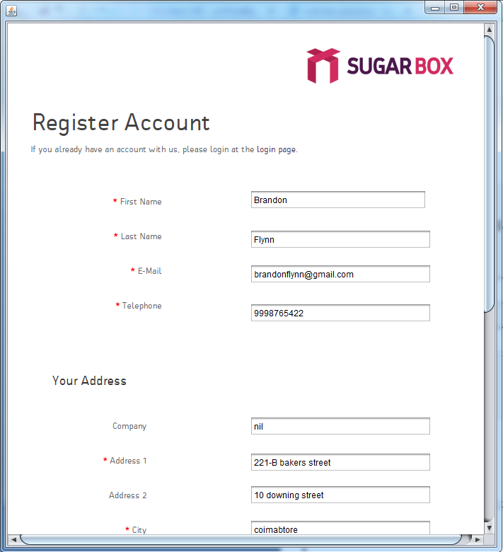

**FORM 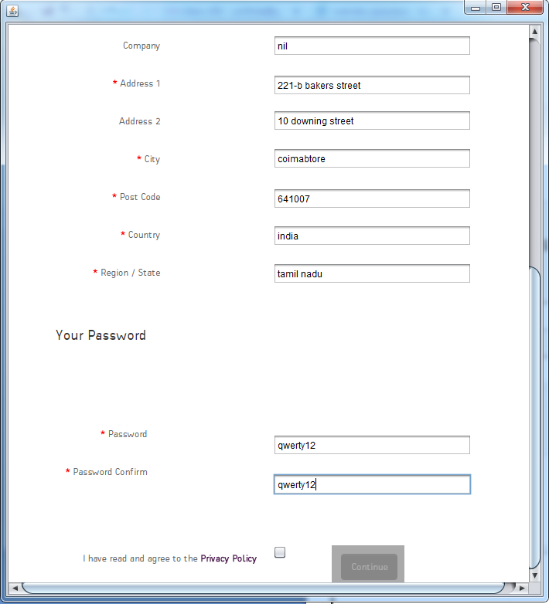3: LOGINACCOUNT**

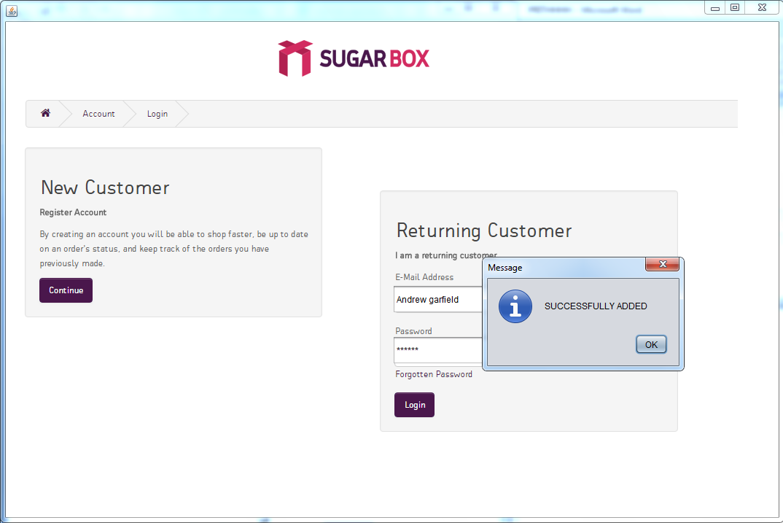

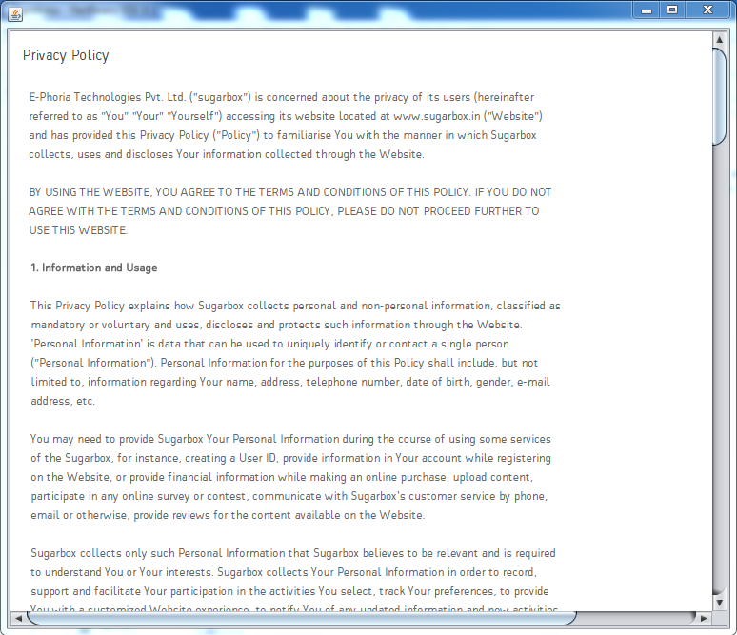**FORM 4: PRIVACYPOLICY**

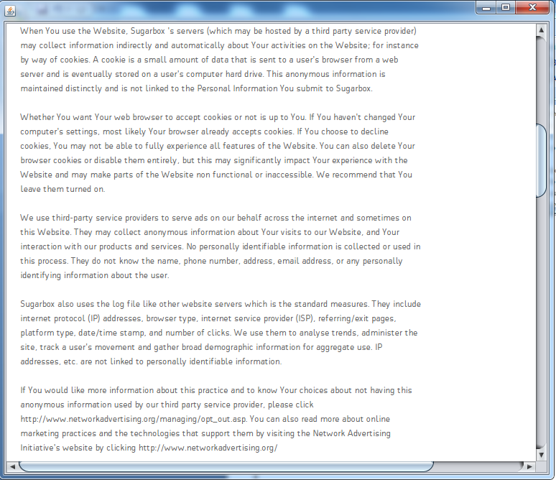

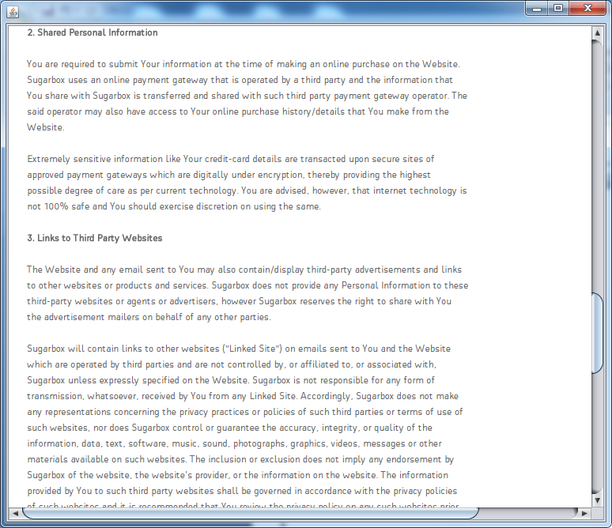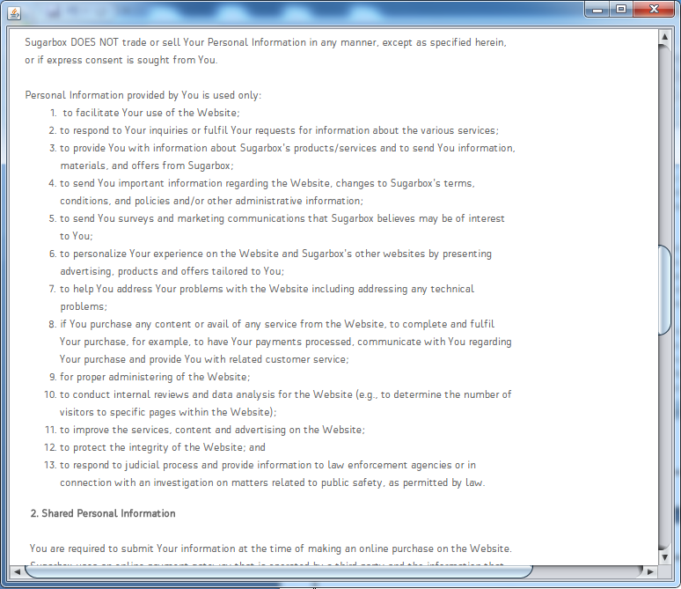

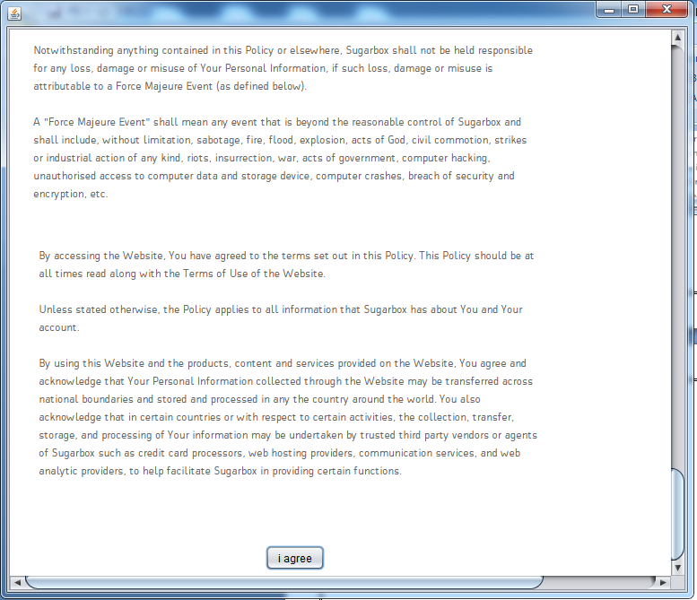

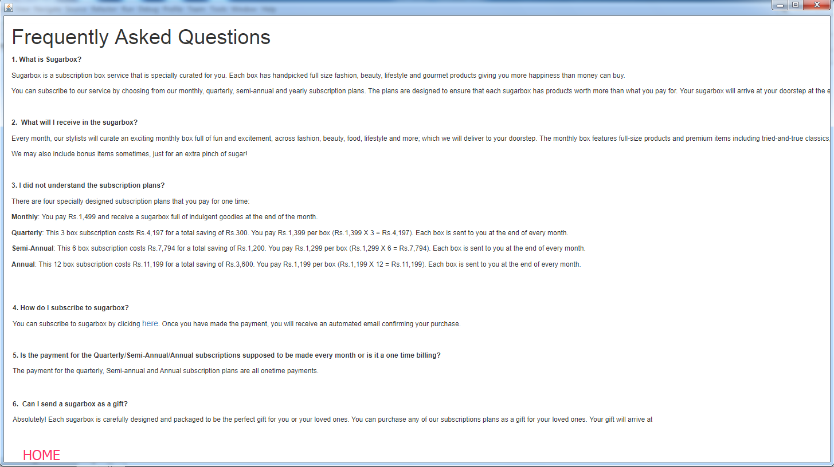**FOR M 5: FAQS**

**FORM 6: LIMITED EDITION**

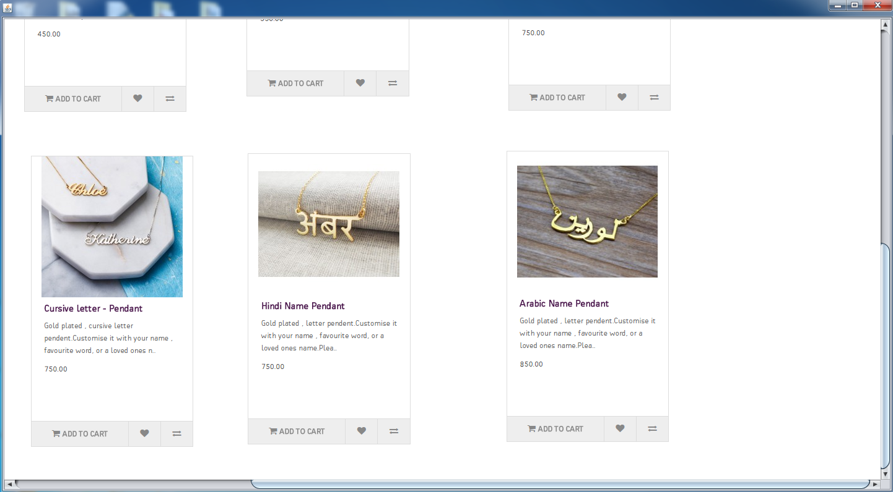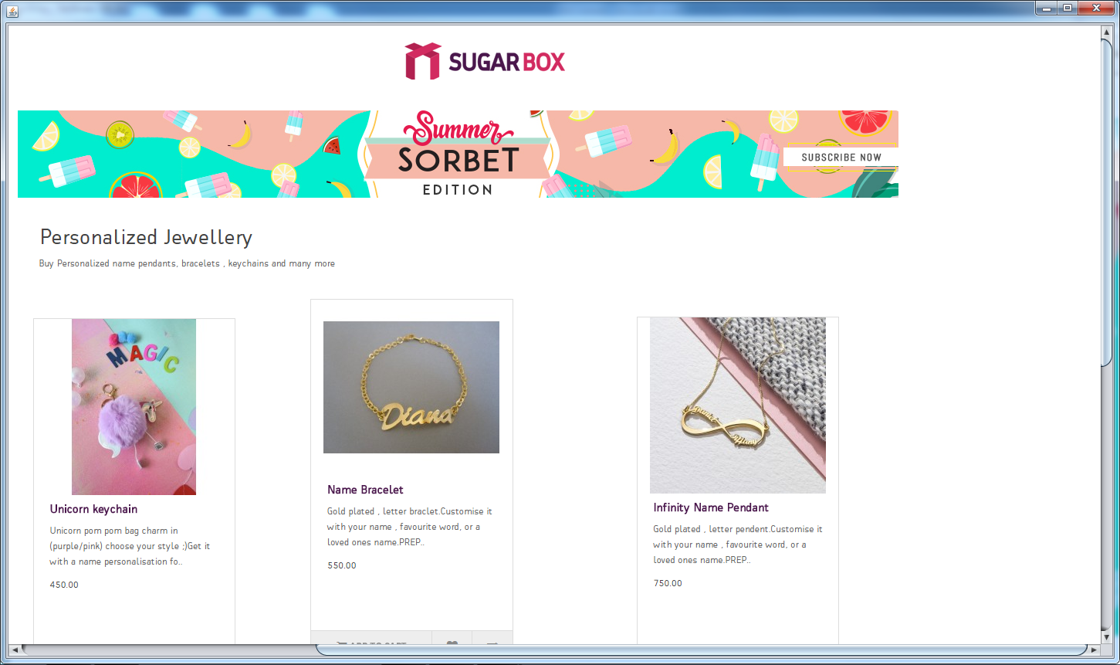

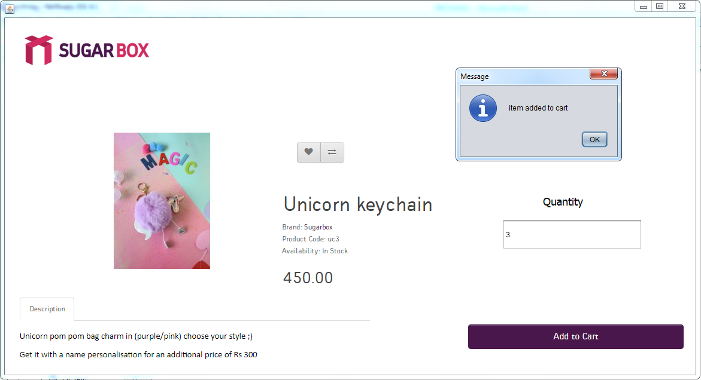**FORM 7: UNICORN KEYCHAIN**

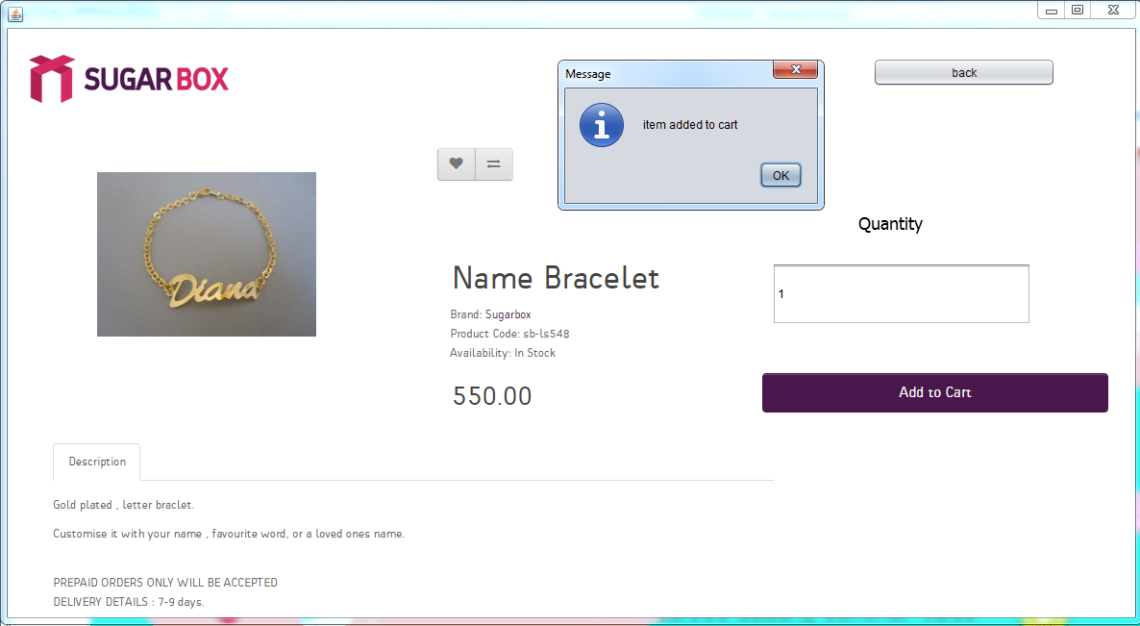**FORM 8: NAME BRACELET**

**FORM 9: INFINITY NAME PENDANT**

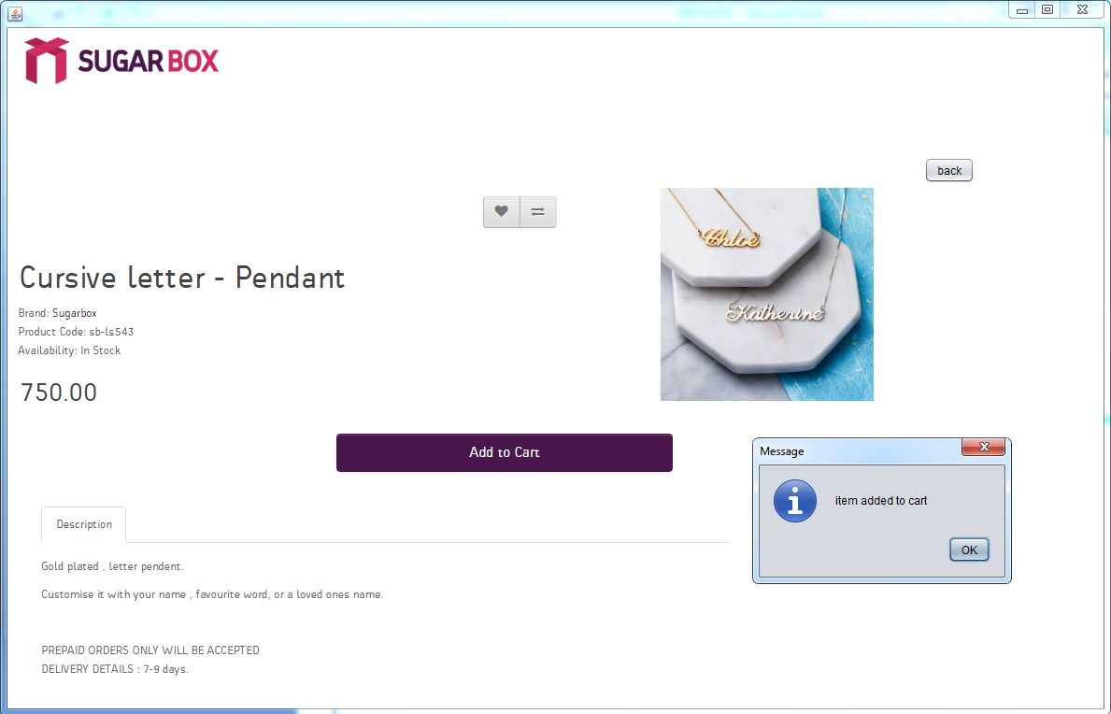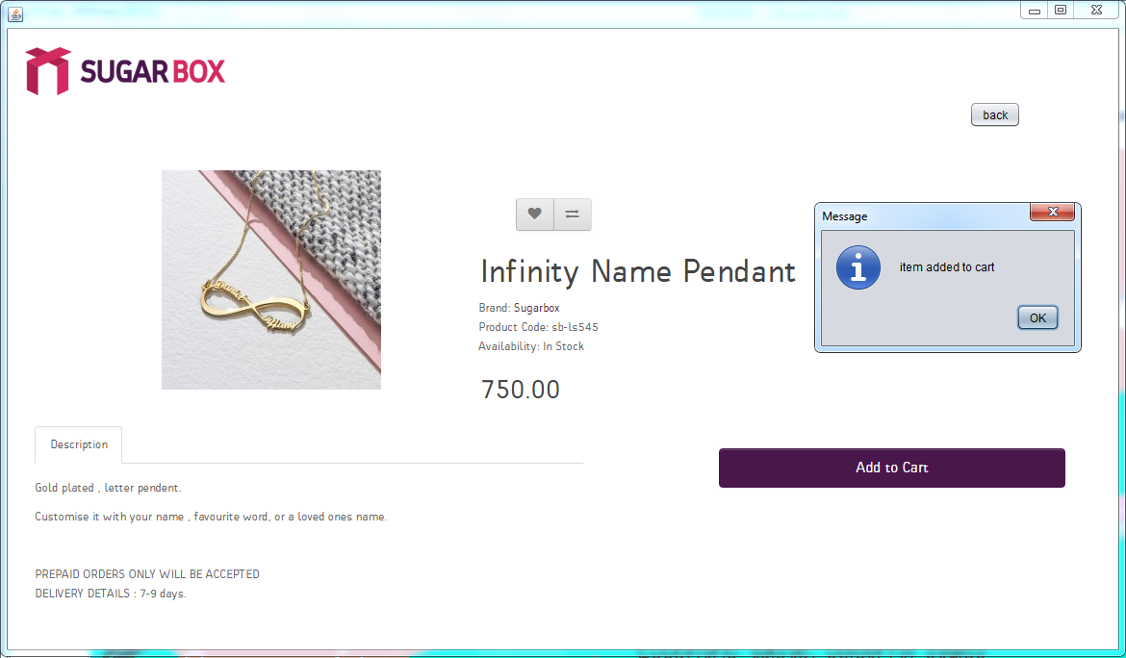**FORM 10: CURSIVE LETTER PENDANT**

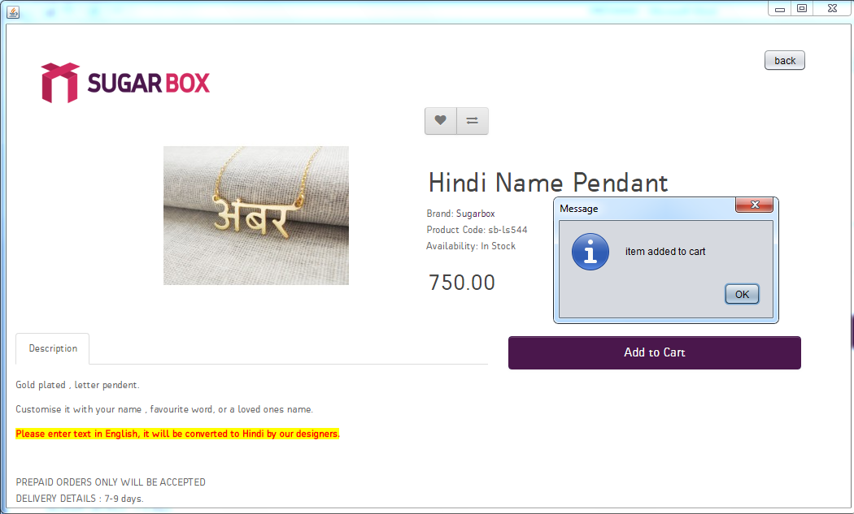**FORM 11: HINDI NAME PENDANT**

**FORM 12: ARABIC NAME PENDANT**

**FORM 13: GADGETS**



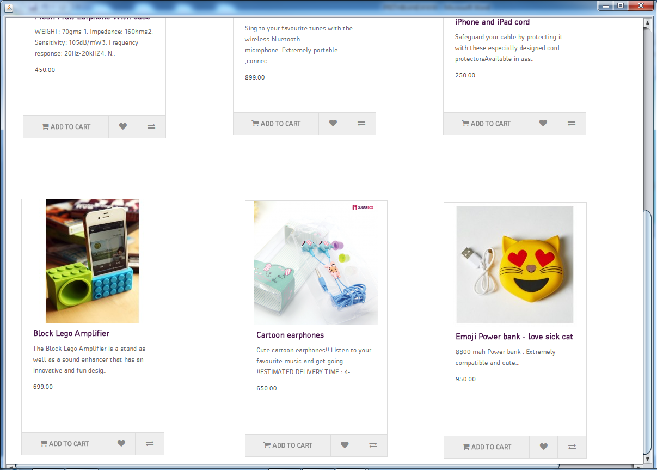

**FORM 14: CASES**

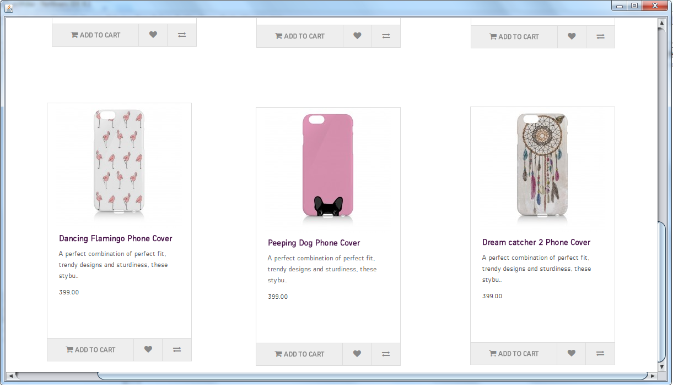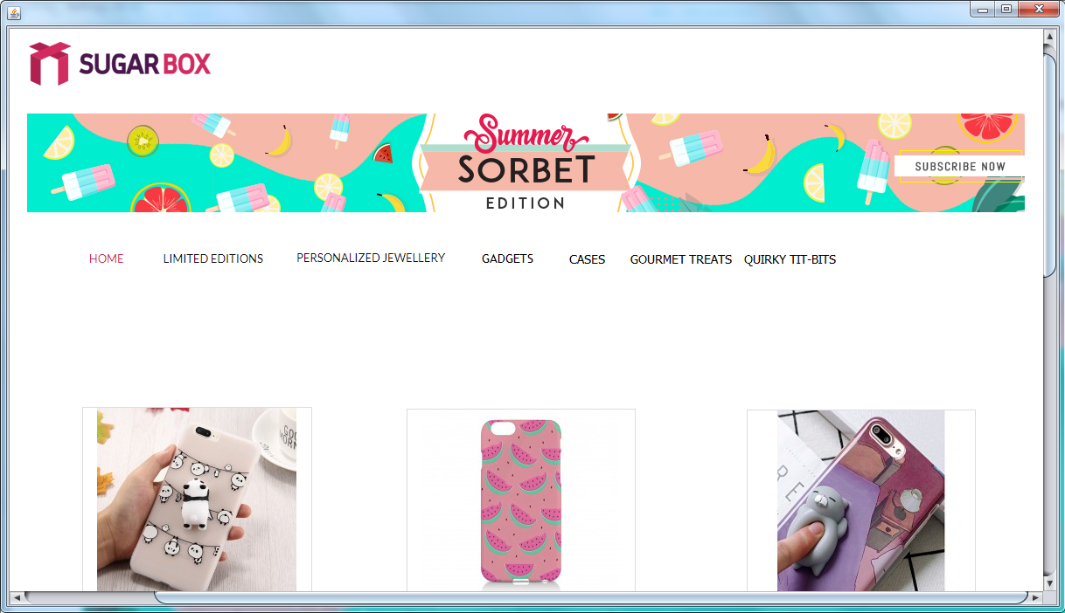

**FORM 16: CASES2**

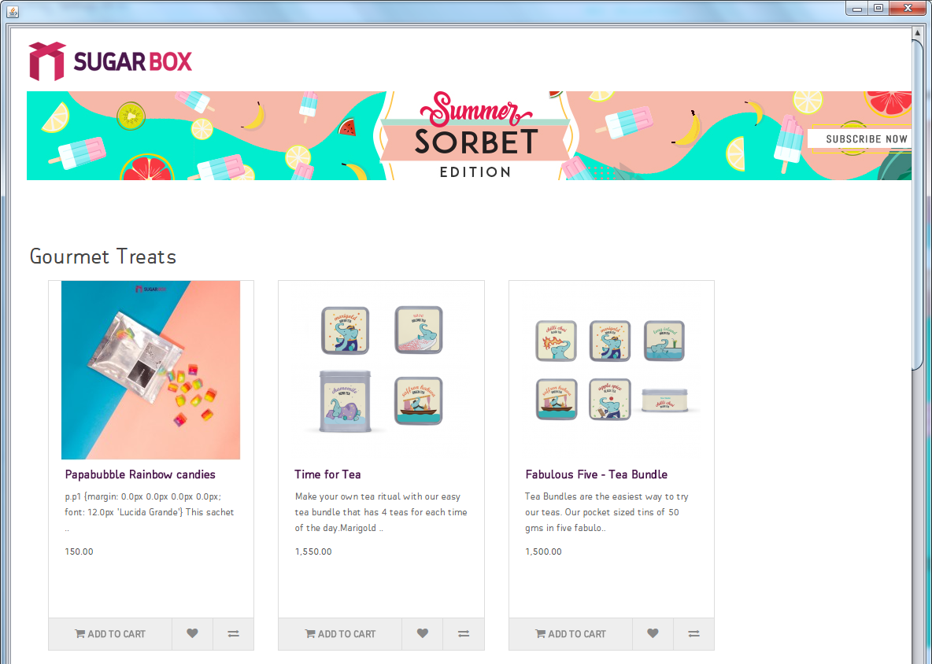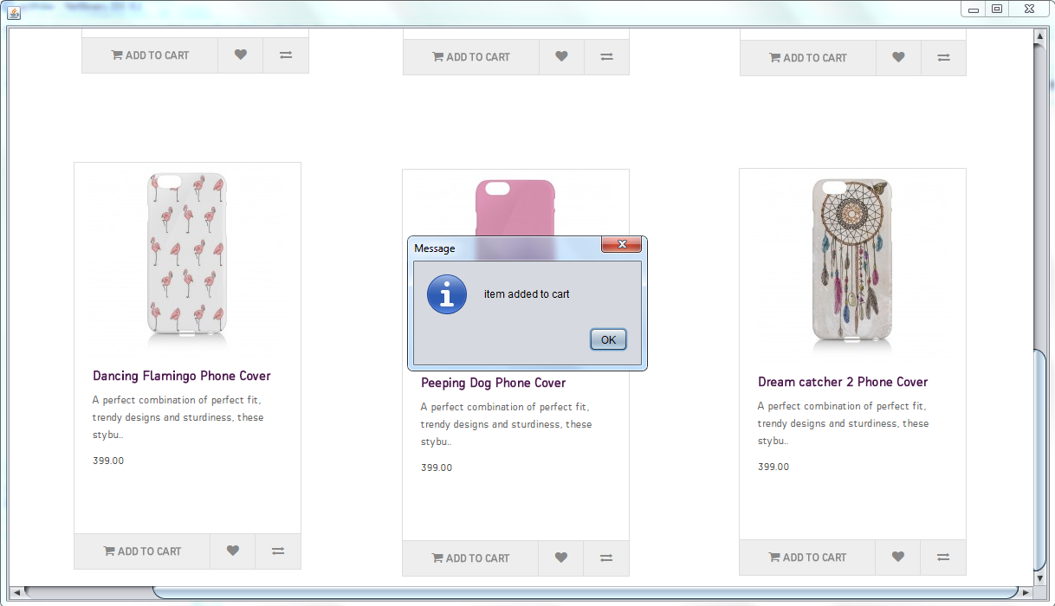

**FORM 17: GOURMET TREATS**